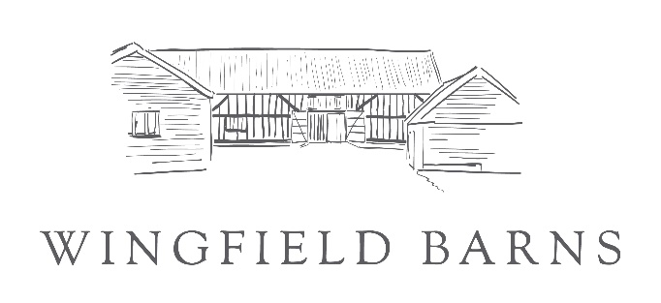
Application Form 2022 – Christmas Market
Please complete all fields of the application form in ‘CAPITAL LETTERS’ and return the application form with the required supporting documentation to office.manager@wingfieldbarns.co.uk
or by post to: Wingfield Barns, Church Road, Wingfield, Suffolk IP21 5RA

Your Details
Applicant’s Full Name

Company Name

Full Address and postcode

Did you attend our 2021 Market | If yes and details are the same you do not need  to complete details in red– state ‘same’ here:
Website address

Telephone No
Email address
Mobile No
Full description of the products

Is your Product locally sourced or produced Please state where
Charity Registration No. (Charity only)
For exhibitors handling consumable products and caterers only: | Local Authority/Address | Food Hygiene Rating
Type of food you are offering

Are you cooking/preparing food on site | Y/N

Application Form 2021 continued – Christmas Market
Stallholder
Zone | Stand Number | Price
1A Great Barn
1B Great Barn Foyer
2A Studio 1
2B Studio 2
3A Courtyard
3B Front
4A Studio 4

Furniture & Power | Quantity  (state 0 if not required)
Single folding chair
Trestle table
Single 13amp or 16amp socket

Caterer
Zone | Stand Number | Price
Outside Space
Terrace
Courtyard
Lawn
Tables 6ft x 2ft trestle
Single folding chair
Single 13amp or 16amp socket

Please note chairs are provided free of charge however be aware of your space limitations when ordering eg., single stand space has room for one trestle and 2 chairs.

