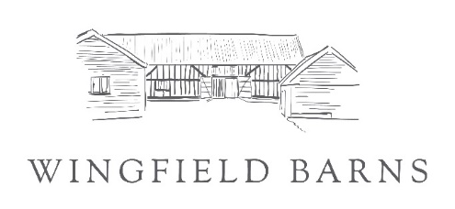Application Form 2024 – Christmas Market
OFFICE USE:
Please complete all fields of the application form in ‘CAPITAL LETTERS’ and return the application form with the required supporting documentation to office.manager@wingfieldbarns.co.uk
or by post to: Wingfield Barns, Church Road, Wingfield, Suffolk IP21 5RA

Your Details
Applicant’s Full Name

Company Name

Full Address and postcode

Did you attend our 2023 Market | If yes and details are the same you do not need to complete details in red – state ‘same’:
Website address
Telephone No
Email address
Mobile No
Full description of the products
Is your Product locally sourced or produced Please state where
Charity Registration No. (Charity only)
For caterers/exhibitors handling consumable products/cooking on site | Local Authority/Address | Food Hygiene Rating
Type of food you are offering
Furniture & Power *  Max 2 chairs & 1 table per straight stand | Quantity  (state 0 if not required)
Single chair
Trestle table
Single 13amp or 16amp socket
Stall
Zone | Stand Number  & Price
1A Great Barn
1B Great Barn Foyer
2A Studio 1
2B Studio 2
3A Courtyard
4A Studio 4
* A charge of £5 for the supply of an extension lead with power
Caterer
Zone | Stand Number | Price
Outside Space
Courtyard
Tables 6ft x 2ft trestle
Single folding chair
Single 13amp or 16amp socket (£5)

